Directions: Complete the song below with lyrics of your own. Think about the tempo, rhythms, articulation markings and theme when choosing lyrics that fit the melody.

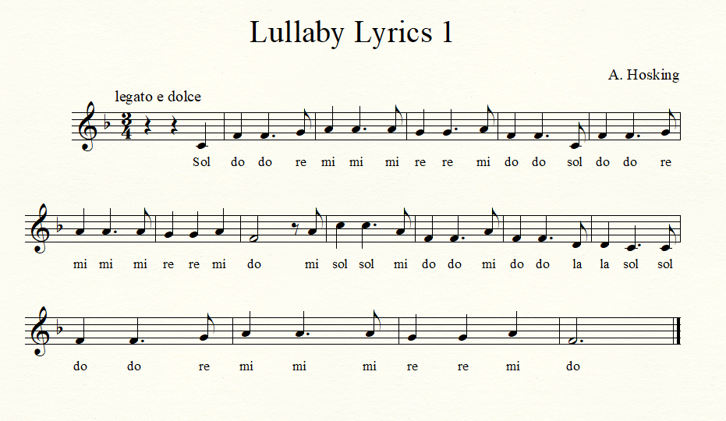

arr.

