Directions: Record a video of yourself performing the rhythm below. Or create your own rhythmic pattern to perform. You can use conventional instruments for your performance like: clapping, spoken syllables, or play your instrument. Or, you can use unconventional items for your performance like: spoons, cups, toys or anything else in and around your house. Be as creative as you like!
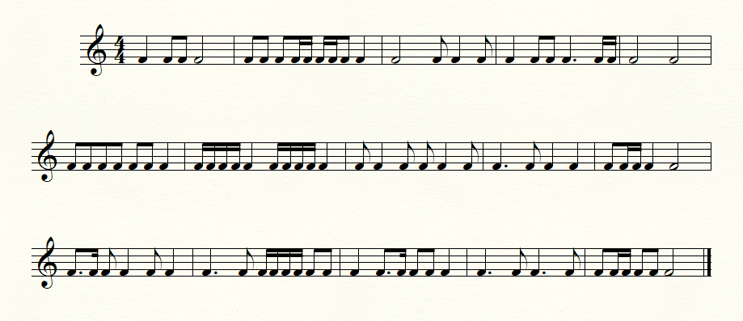
Rhythm example 1:

Or create your own rhythm below:

